***Microsoft Sentinel Logstash Output plugin Installation Guide***

We Download the “logstash-offline-plugins-8.4.3.zip”, which contains the Microsoft Sentinel output Plugin

* We save the “logstash-offline-plugins-8.4.3.zip” to a location which we can pinpoint in the installation command below. For example, we can put in inside the /usr/share/logstash
* We go the folder that logstash is installed with cd and then we run with elevated privileges the example command:

sudo /usr/share/logstash/bin/logstash-plugin install <file:///usr/share/logstash/logstash-offline-plugins-8.4.3.zip>

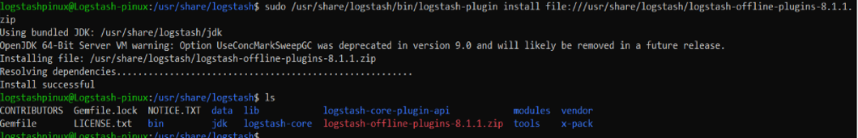

Reference: <https://www.elastic.co/guide/en/logstash/current/offline-plugins.html>